Q 1. Select unique job from EMP table.

Ans : select distinct job from employee;

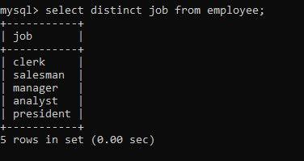

Q 2. List the details of the emps in asc order of the Dptnos and desc of Jobs?  
Ans : select * from employee order by Deptno asc; select * from order by job desc;

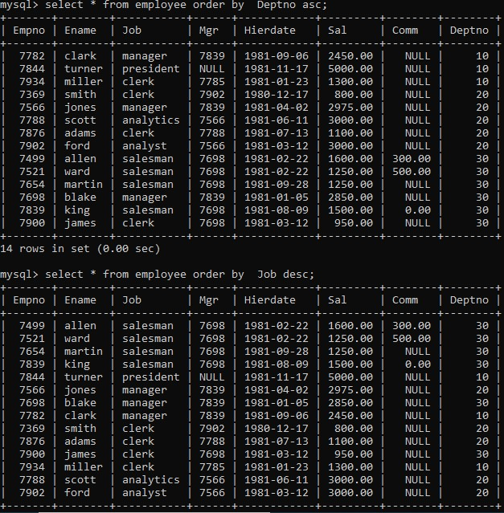

Q 3. Display all the unique job groups in the descending order?

Ans :select distinct job from employee order by job desc;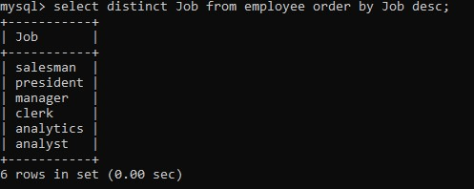

Q 4. List the emps who joined before 1981

Ans : select * from employee where HireDate <(‘1981-01-01’);

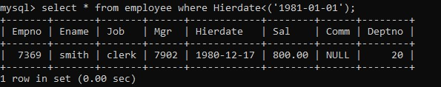

Q 5. List the Empno, Ename, Sal, Daily sal of all emps in the asc order of Annsal.

Ans : select Empno,Ename,sal,sal/30,12* annsal from employee order by annsal asc;

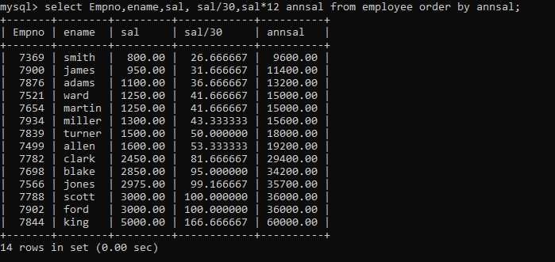

Q 6. List the Empno, Ename, Sal, Exp of all emps working for Mgr 7369.

Ans:- select * from employee where Empno like “7369”;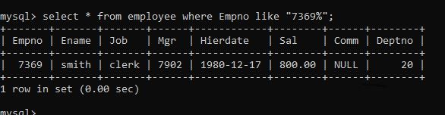

Q 7. Display all the details of the emps who’s Comm. Is more than their Sal?

Ans : select * from employee where comm > sal;

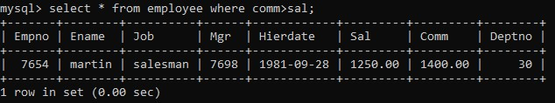

Q 8. List the emps who are either ‘CLERK’ or ‘ANALYST’ in the Desc order.

Ans : Select * from employee where Job = ‘ clerk’ or Job=’analyst’ order by job desc;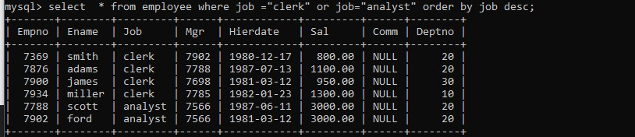

Q 9. List the emps Who Annual sal ranging from 22000 and 45000.

Ans : select * from employee where 12*sal between 22000 and 45000;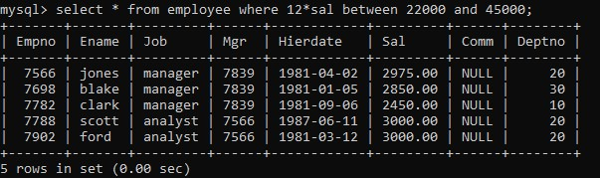

Q 10. List the Enames those are starting with ‘S’ and with five characters.

Ans : select Ename from employee where Ename like ‘s%’;

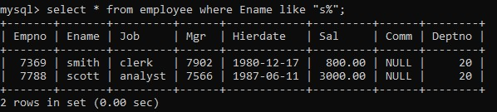

Q 11. List the emps whose Empno not starting with digit78.

Ans : select * from employee where Empno not like ‘78%’;

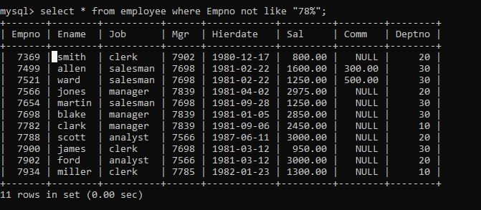

Q 12. List all the Clerks of Deptno 20.

Ans : select * from employee where job=”clerk” and Deptno=20;

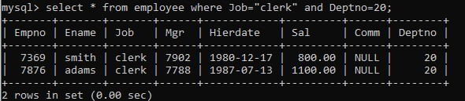

Q 13. List the Emps of Deptno 20 who’s Jobs are same as Deptno10.

Ans : select * from employee where Deptno=10 and job in(select job from employee where Deptno=20);

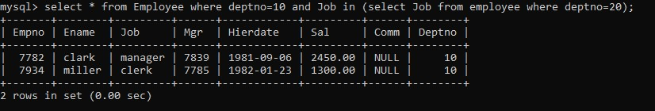

Q14List the Emps who’s Sal is same as FORD or SMITH in desc order of Sal.

Ans: select * from employee where sal in(select sal from employee where(Ename="smith" or Ename="ford")order by sal desc);

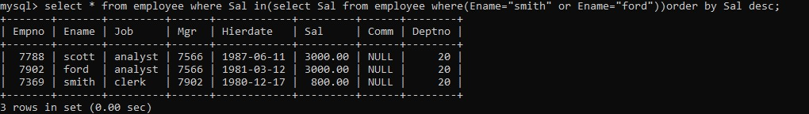

Q 15. List the emps whose jobs same as SMITH or ALLEN.

Ans : select Ename,job from employee where job =’clerk’ or job= ‘salesman’ ;

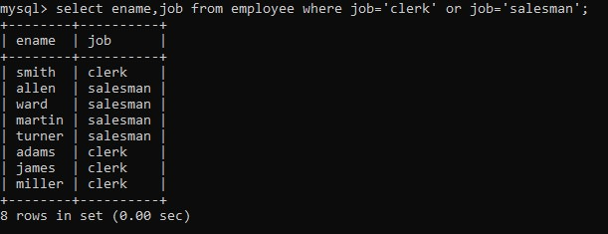

Q 16. Any jobs of deptno 10 those that are not found in deptno 20.

Ans: select * from employee where Deptno =10 and job not in (select job from employee where deptno=20);

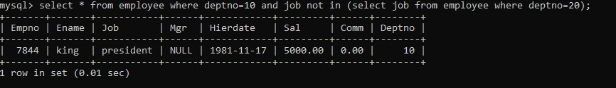

Q 17. Find the highest sal of EMP table.

Ans : select * from employee where Sal=(select Max(Sal) from employee);

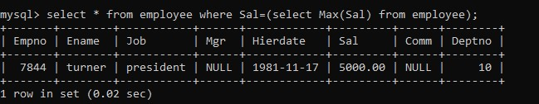

Q 18. Find details of highest paid employee.

Ans: select * from employee where Sal=(select Max(Sal) from employee);

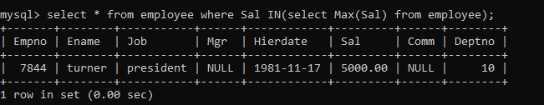

Q 19. Find the total sal given to the MGR.

Ans: select sum(sal) from employee where job=’manager’;

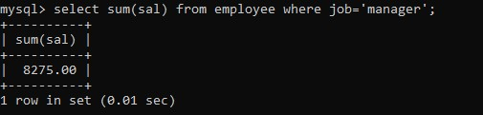

Q 20. List the emps whose names contains ‘A’.

Ans: select * from employee where Ename like “a%”;

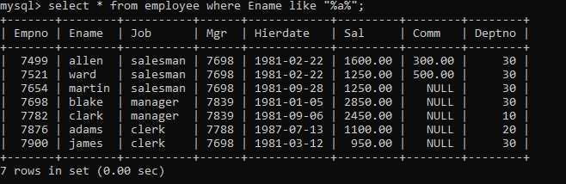

Q 21.Find all the emps who earn the minimum Salary for each job wise in ascending order.

Ans : select * from employee where sal in(select min(sal) from employee group by job) order by sal asc;

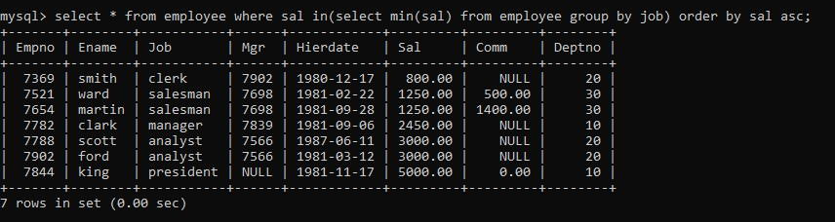

Q 22. List the emps whose sal greater than Blake’s sal.

Ans : select * from employee where Sal>(select Sal from employee where Ename=”Blake”;

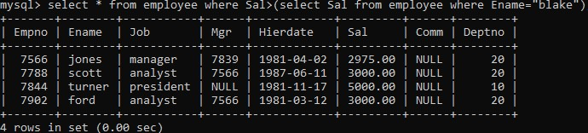

Q 23. Create view v1 to select ename, job, dname, loc whose deptno are same.

ANS: create view v1 as select Ename,Job,Dname,loc from Employee inner join Dept on Employee.Deptno=Dept.Deptno;

Select * from v1;

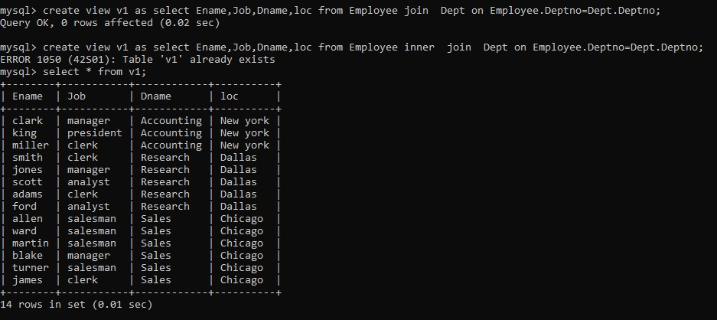

Q24. Create a procedure with dno as input parameter to fetch ename and dname.

Ans:- create procedure fetch_Employee_Department(in dno int)

Begin

Select e.Ename,d.Dname from employee e join dept d on e.Deptno=d.Deptno where e.Deptno=dno;

End//

Delimiter:

Call fetch_employee_Department(20);

Q25. Add column Pin with bigint data type in table student.

Ans:- alter table student add column Pin biginit;

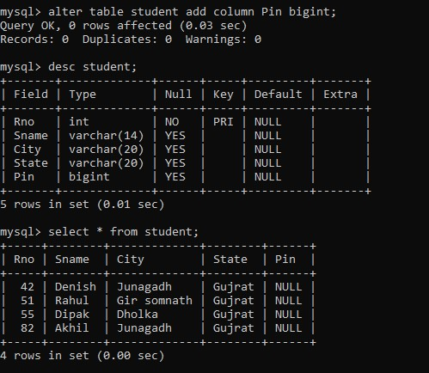

Q26. Modify the student table to change the sname length from 14 to 40. Create trigger to insert data in emp_log table whenever any update of sal in EMP table. You can set action as ‘New Salary’.

Ans:- alter table student modify Sname varchar(40);

Ans;- delimiter //

Create trigger emp_salary_update_trigger after update on employee for each row

Begin

If old. Sal !=New. Sal then

Insert into emp_log (Emp_id,Log_date,New_salary,action)

Values (new.Empno,now(), new.Sal,’new Salary’);

End if;

End//

Ans:- update employee set Sal=10000 where Empno=7844;

